Program 5
Apply positioning methods of elements on a webpage with div elements and their corresponding classes using two external stylesheets. Compare the output with absolute, and relative positioning of div elements.

index.html (relative):
<!DOCTYPE html>
<html lang="en">
<head>
<meta charset="UTF-8">
<title>Positioning relative</title>

<!-- External Stylesheets -->
<link rel="stylesheet" href="relative.css">

</head>
<body>
<h1>Positioning with DIVs (RELATIVE)</h1>

<div class="container">
<div class="box box1">Box 1</div>
<div class="box box2">Box 2</div>
<div class="box box3">Box 3</div>
</div>
</body>
</html>

relative.css
/* relative.css */
body {
font-family: Arial, sans-serif;
background: #f0f0f0;
}

.container {
width: 600px;
height: 300px;
border: 2px solid black;
margin: 30px auto;
background: white;
position: relative;
}

.box {
width: 100px;
height: 100px;
color: white;
text-align: center;
line-height: 100px;
font-weight: bold;
}

.box1 {
background: red;
position: relative;
top: 20px;
left: 30px;
}

.box2 {
background: blue;
position: relative;
top: 40px;
left: 60px;
}

.box3 {
background: green;
position: relative;
top: 60px;
left: 90px;
}

OUTPUT:
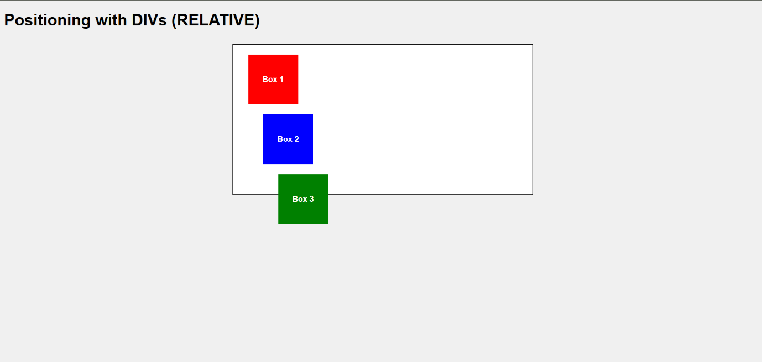

- Each box shifts from its original flow position by top and left.
- The boxes still occupy their original space, so they appear staggered downwards.
- Example: Box 2 moves relative to where it would normally sit (under Box 1).

index2.html (Absolut):
<!DOCTYPE html>
<html lang="en">
<head>
<meta charset="UTF-8">
<title>Positioning absolute</title>

<!-- External Stylesheets -->
<link rel="stylesheet" href="absolute.css">

</head>
<body>
<h1>Positioning with DIVs (ABSOLUTE)</h1>

<div class="container">
<div class="box box1">Box 1</div>
<div class="box box2">Box 2</div>
<div class="box box3">Box 3</div>
</div>
</body>
</html>

absolute.html:
/* absolute.css */
body {
font-family: Arial, sans-serif;
background: #f0f0f0;
}

.container {
width: 600px;
height: 300px;
border: 2px solid black;
margin: 30px auto;
background: white;
position: relative;
}

.box {
width: 100px;
height: 100px;
color: white;
text-align: center;
line-height: 100px;
font-weight: bold;
}

.box1 {
background: red;
position: absolute;
top: 20px;
left: 30px;
}

.box2 {
background: blue;
position: absolute;
top: 40px;
left: 60px;
}

.box3 {
background: green;
position: absolute;
top: 60px;
left: 90px;
}

Output:
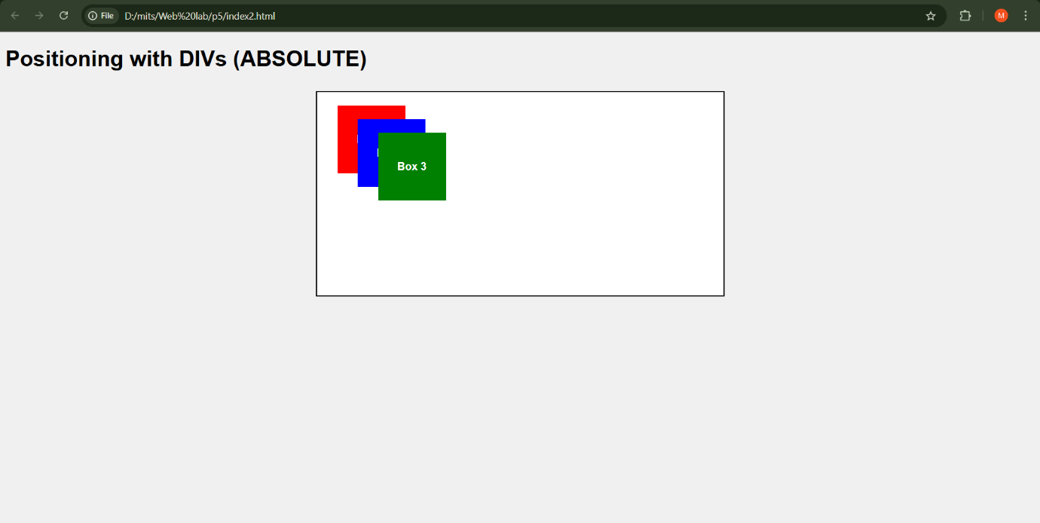
- Boxes are positioned relative to the container’s top-left corner.
- They do not leave space in normal flow.
- As a result, the boxes may overlap inside the container depending on coordinates.

